Chapter 14, Problem 42.

For the circuits in Fig. 14.81, find the resonant frequency ω₀, the quality factor Q, and the bandwidth B.

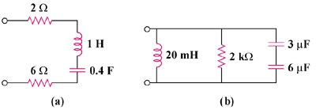

Figure 14.81
For Prob. 14.42.

